Task 2 – Developing the Prototype
Introduction and Development Overview
Purpose of the Prototype:
The whole point of this prototype was to build a working website for Greenfield Local Hub. They are a group of local farmers and food producers. The client wanted a platform where customers could buy and promote local food and see exactly what they were paying for. They also wanted producers to be able to manage their own stock and see what orders had come in.
Client Requirements:
Looking at the task brief, I had to include quite a few things. Firstly the site needed to tell customers about the producers, how they grow their food, and why buying locally is a good thing. Then customers needed to be able to browse prod ucts with clear prices and see if something was in stock. They also had to place orders, either for collection or delivery and they needed their own accounts so they could see what they had ordered before.
For the producers, I had to build a dashboard where they could update their stock levels, change product details and view any orders that had been placed for their items.
The client also wanted a few extra features that came from asking their existing customers what they would like. These were order tracking so people could see where their delivery was, a loyalty scheme where you earn points and get discounts, and some accessibility features to help people who might struggle with standard websites. I decided to put in the loyalty scheme properly and added a dark mode and light mode toggle to help with accessibility.
Technologies I Used:
I had to pick some tools to build this prototype and I chose ones that work nicely together and are used a lot in real jobs.
For the frontend – that is the bit the user actually sees and clicks on. I used React with JavaScript. This let me build a site that responds well to different screen sizes, and I could break everything down into small, reusable chunks of code. That also made it easier when I had to fix things.
For the backend, the part that runs on the server, deals with logins, fetches products from the database, and saves orders, I used Node.js with Express. This handled all the requests coming from the frontend and sent back the right data.
For the database, I went with SQLite3 as it is easy to set up and saves. It saves data to a file on the server, so I did not need to set up a separate database program. That kept things simple but still meant that when I restarted the server, my data did not just disappear.
I also added a map using Leaflet, which works with OpenStreetMap. This map shows where each producer is located for the customers who want to know where their food comes from.
Development Approach:
An iterative approach was used for the development process because there were numerous parts of the website to be developed that should work together including the product page, the shopping basket, and checkout, the customers account information, producer dashboard and loyalty scheme. Doing it all together and testing at the end could be very risky since if anything went wrong, I would not know which component caused the problem.
each phase of the website was done separately until completion after which it was tested. I began by developing the user interface and navigation menu, followed by the products page, the basket and checkout, customer account log-in and sign-up, producer dashboard, then the loyalty scheme and finally the mapping API. As soon as I completed each phase, I conducted a test. Any bug was quickly and immediately addressed and fixed before moving to the next part. This saved me a lot of time since the issues were fixed out before becoming difficult.
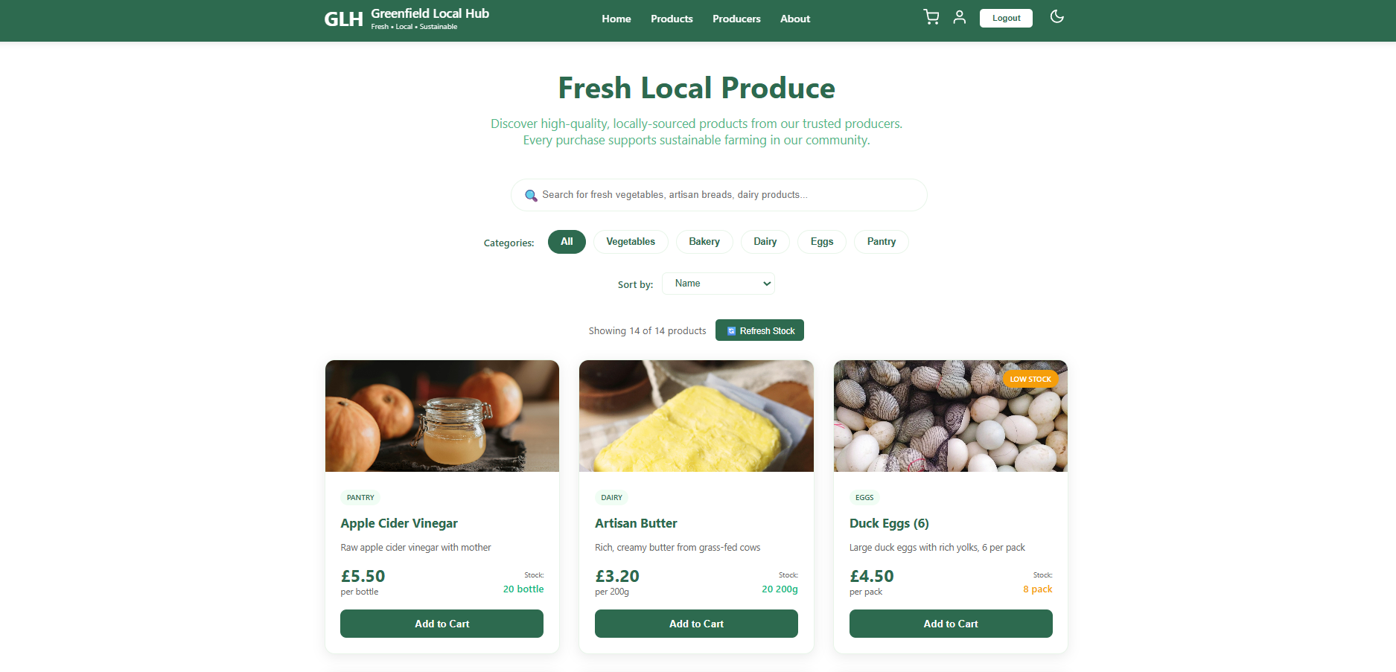

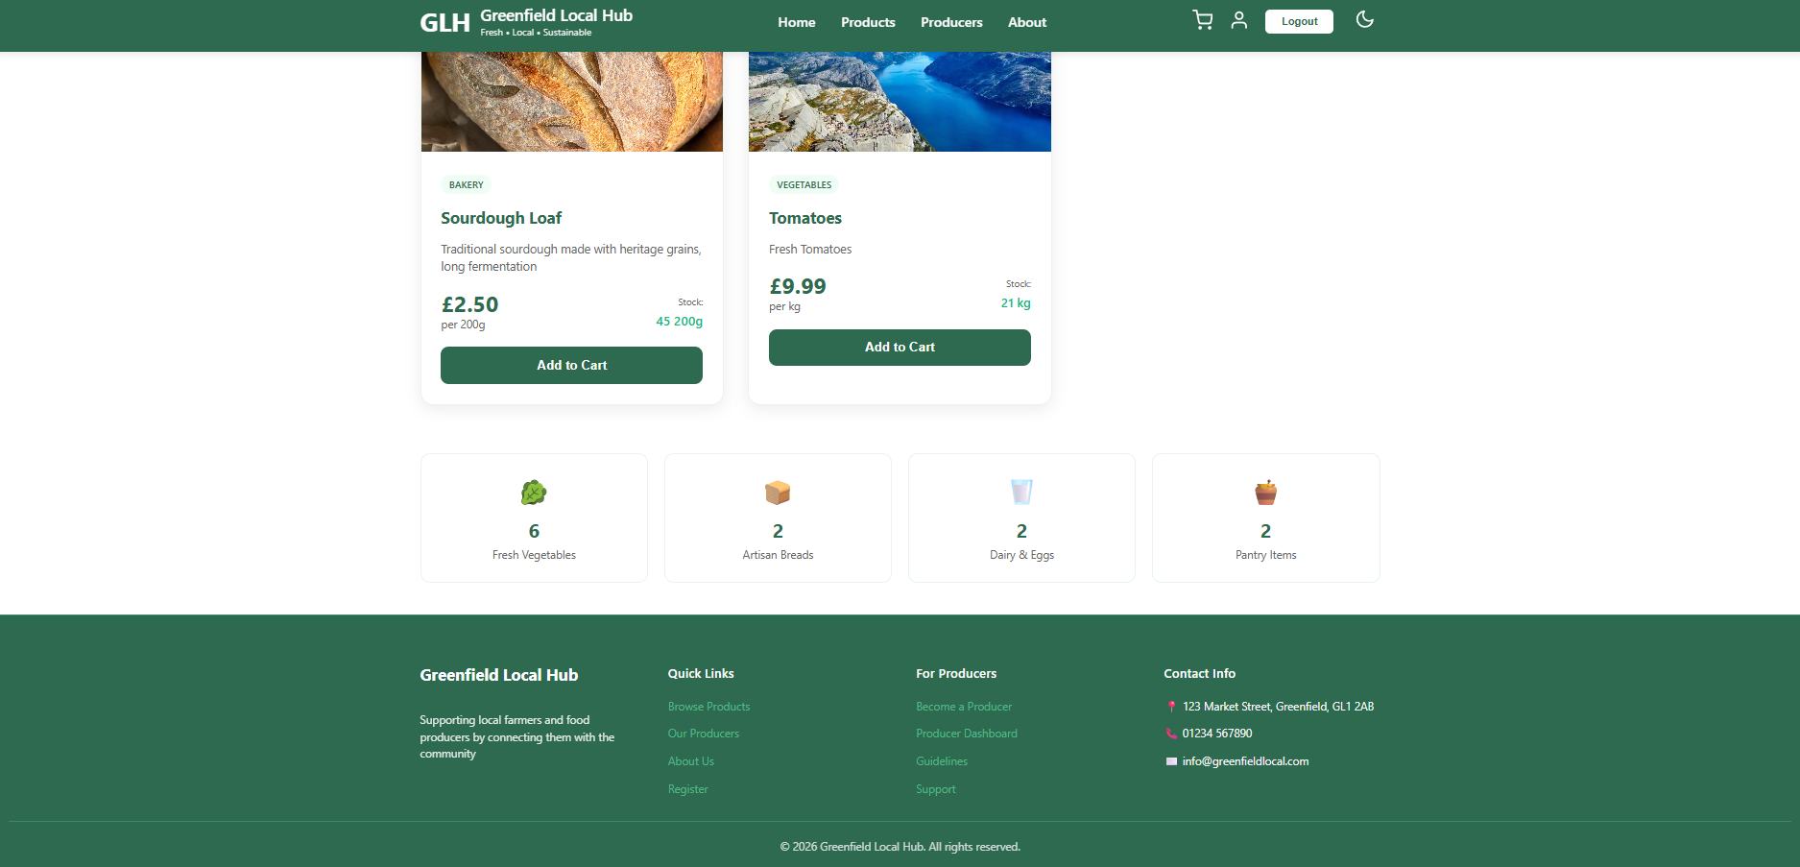
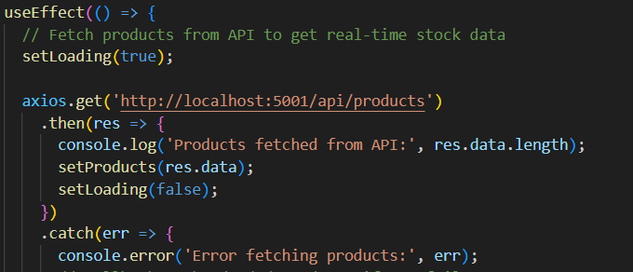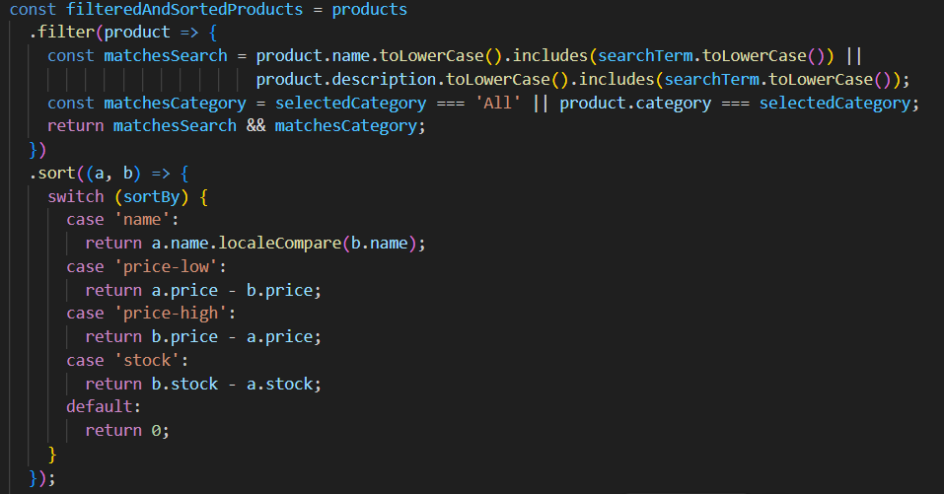
When the Products page loads it sends a request to my backend to get all the Products from the database. I used axios because it is easy to use. If the request does not work for some reason the page uses a list of Products that I already put in the code. This way the customer can still see some Products of a page that does not work.
Once the Products are loaded the page looks at what the customer types into the search bar and which category button they click. It then shows the customer the products that match what they are looking for. The page also puts the products in order based on what the customer picks from the menu. I decided to do this on the frontend with the products not on the backend. This makes the Products page feel faster because the customer does not have to wait for the server to respond every time they change something. The customer can just keep looking at the Products without any delay.
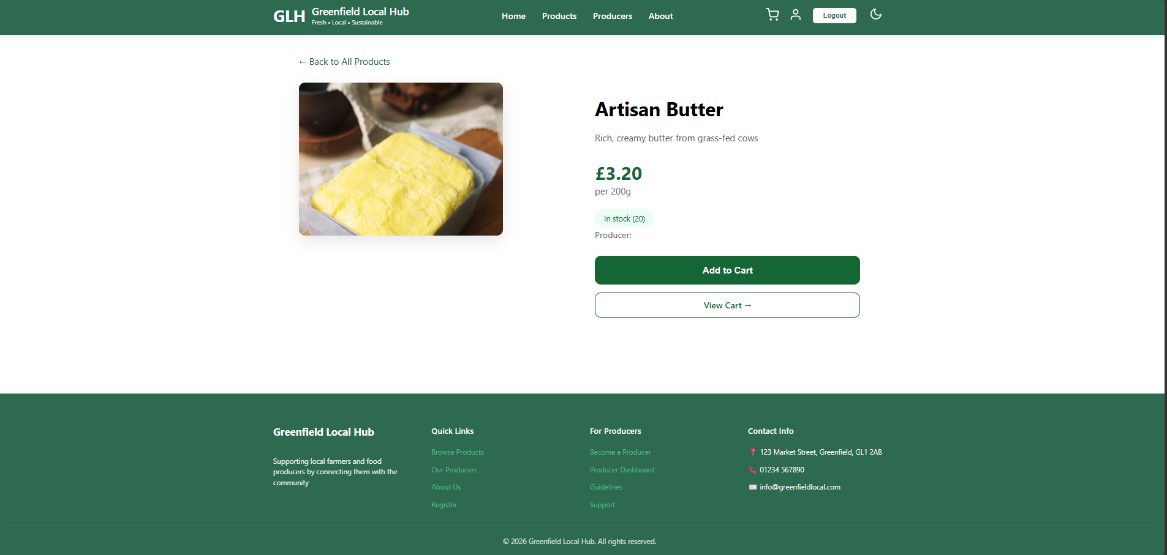
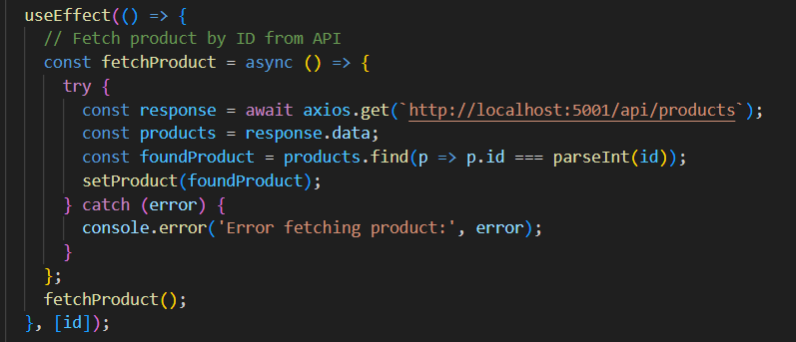
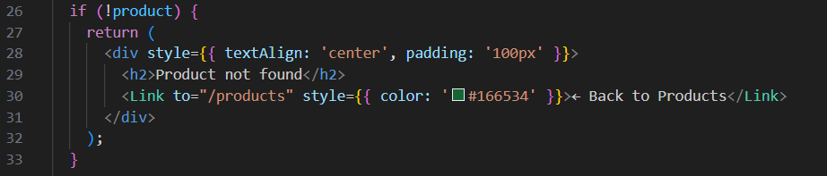
When a customer clicks on a product from the Products page they get taken to the Product Details page. The web address has the product ID number in it like product/5. The code sees this ID. It Then asks my backend for all the products. The code gets the list of products. Then looks through it to find the product with the matching ID. When it finds the product it saves the Product Details so they can be shown on the screen. If a customer types a web address for a product that does not exist or if the product was removed from the database the code will not find the product. In that situation the Product Details page will not show a page or a broken screen. Instead the Product Details page shows a friendly "Product not found" message and gives the customer a button to go back, to the Products page. This gives the site more professional look.
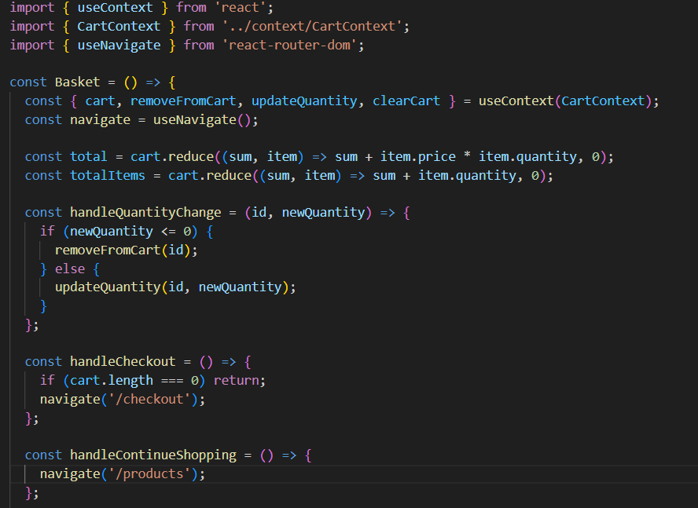
The Basket page keeps track of everything the customer has added. When the page loads it checks the cart data stored in a shared memory called Context. This Context is where all pages can get information so items stay in the basket even when the customer moves to another page. The total price is calculated by adding up the price multiplied by the quantity for each item in the basket. This is done using a function that loops through every item. The total number of items is calculated by adding up the quantities. When the customer changes the quantity of an item using the plus and, minus buttons the code checks the quantity. If the customer tries to set the quantity below one the item gets removed from the basket. Otherwise the quantity just gets updated. I did this to avoid confusing the customer with a quantity of zero or less. The page also shows how many loyalty points the customer will earn from this order. The customer earns ten points for every pound spent. For example if the total is £17.40 the customer earns 174 points. This updates instantly as the customer changes quantities so they can always see what they will get.
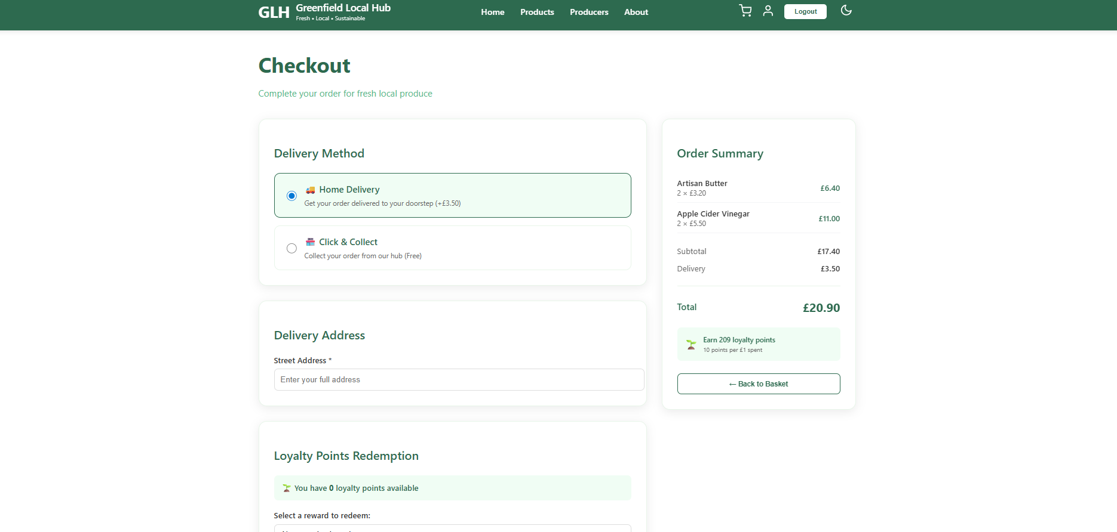
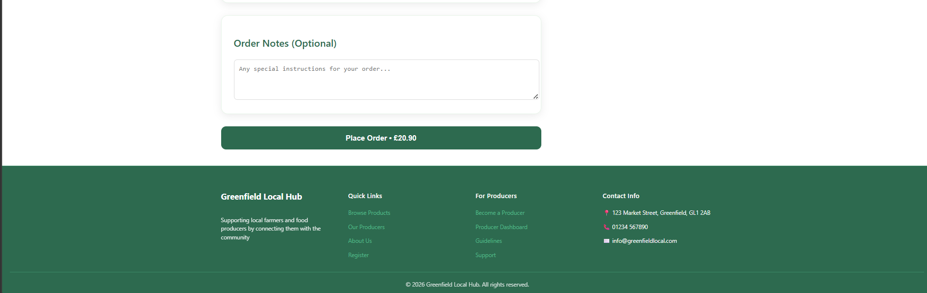
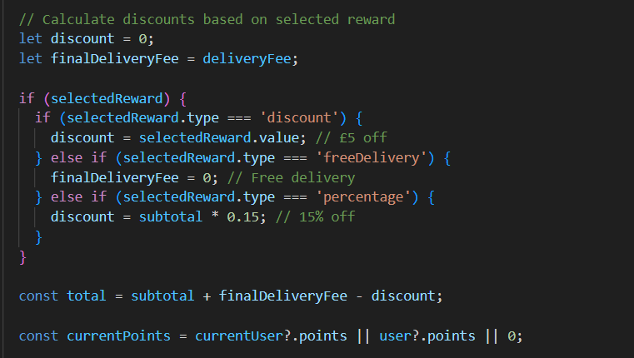
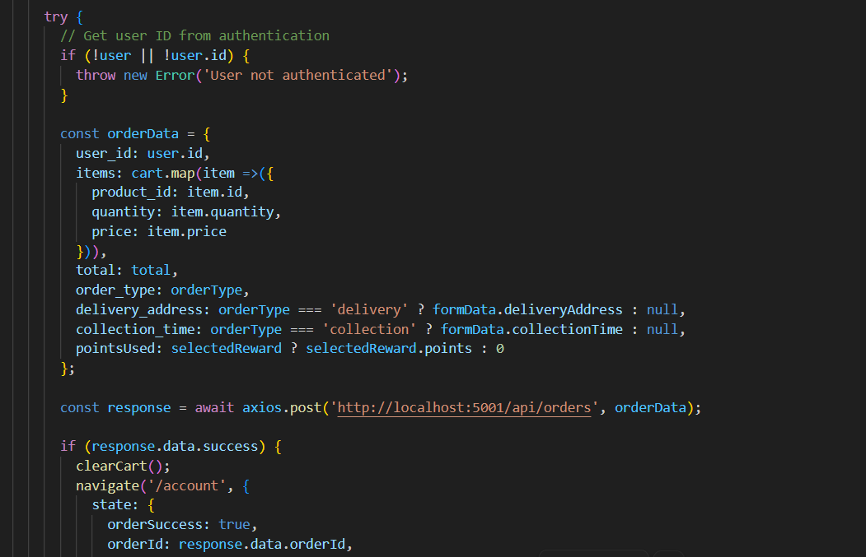
The Checkout page is where the customer finishes their order on the Checkout page. The first thing the Checkout page does is ask the customer whether they want home delivery or click and collect on the Checkout page.If the customer picks delivery on the Checkout page they have to fill in their address and pay a £3.50 for the delivery on the Checkout page. If the customer picks collection on the Checkout page they choose a time slot from the list. There is no delivery fee for the collection on the Checkout page. The Checkout page also lets the customer use their loyalty points on the Checkout page. If the customer has loyalty points on the Checkout page they can pick from three rewards on the Checkout page: £5 off free delivery or 15% off the whole order on the Checkout page. The code checks which reward the customer picked on the Checkout page and works out the discount for the customer on the Checkout page. For a percentage discount on the Checkout page it multiplies the subtotal by 0.15 for the customer on the Checkout page. For delivery on the Checkout page it sets the delivery fee to zero for the customer on the Checkout page. The final total is worked out by adding the subtotal and the delivery fee for the customer on the Checkout page then taking away the discount for the customer on the Checkout page. When the customer clicks the place order button on the Checkout page the Checkout page collects all the information for the customer. This includes the customers ID, the list of items in their basket the amount, whether they chose delivery or collection on the Checkout page and how many loyalty points they used on the Checkout page. It then sends all this to my backend using a POST request, from the Checkout page. If everything goes well the backend saves the order to the database clears the basket and sends the customer to their account page so they can see their order history on the account page.
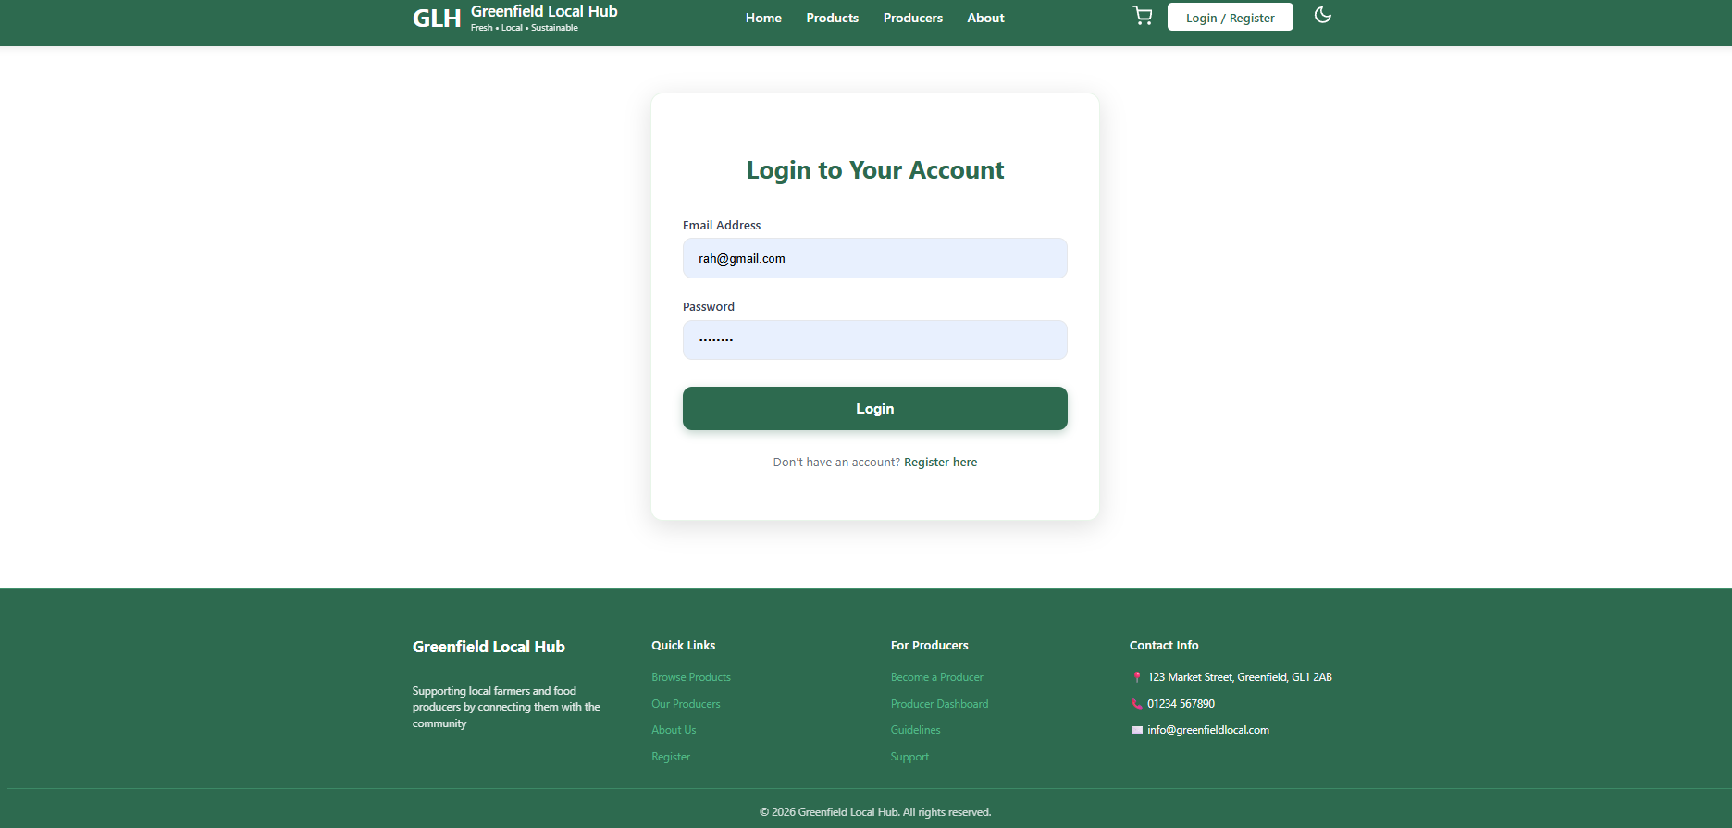
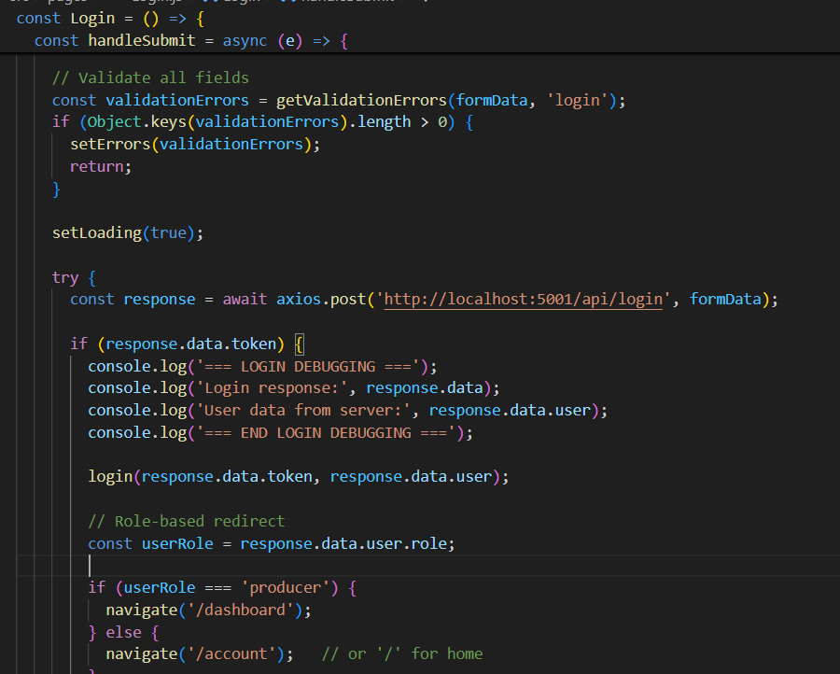
The Login page lets customers and producers sign into their accounts on the Login page. When the user fills in their email and password and clicks the Login button on the Login page the Login page first checks that both fields have been filled in by the user on the Login page. It does this by calling a validation function to validate the fields on the Login page. If something is missing on the Login page it shows an error message on the screen. Stops the form from sending anything to the server from the Login page. This saves the user from waiting for a server response when they have clearly missed a field on the Login page. If the validation passes on the Login page the login page sends a POST request to my backend with the email and password from the login page. The backenthen checks if there is a user with that email in the database and verifies the password for the user on the login page. If the details are correct for the user on the login page the backend sends back a token and the users information to the Login page. The frontend saves this user data using a login function from something called an AuthContext on the Login page. This Context keeps the user logged in as they move between pages on the website. After a login on the login page the page looks at the users role on the Login page. If the role is "producer" for the user on the login page it sends them to the Dashboard where they can manage their products and see orders for the producer. If the role is "customer" for the user on the login page it sends them to the Account page where they can see their order history and loyalty points for the customer. This way each type of user sees the pages that're relevant to them on the website.
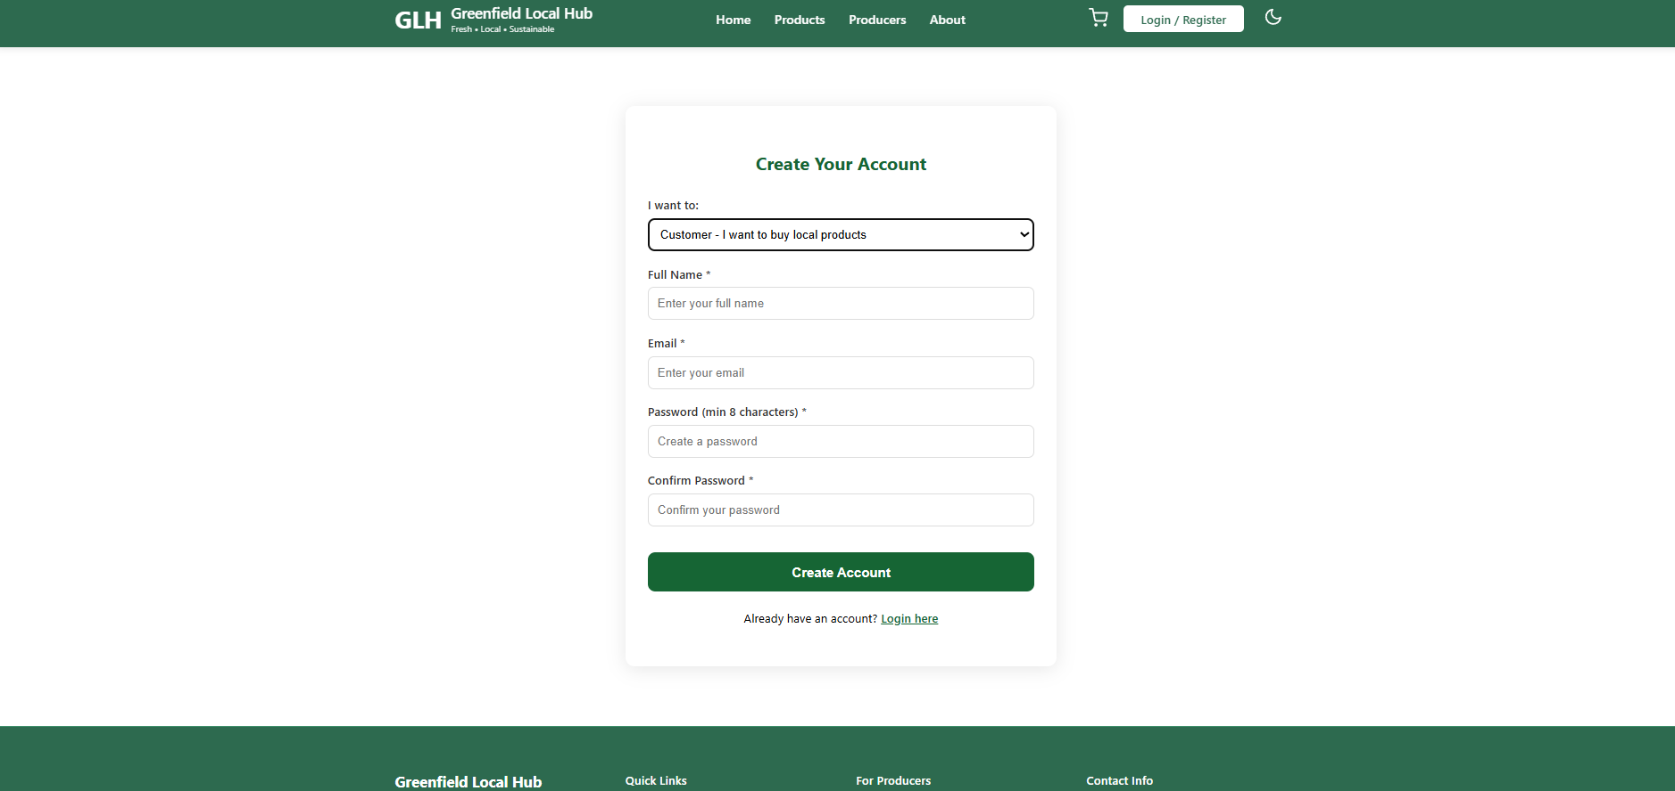
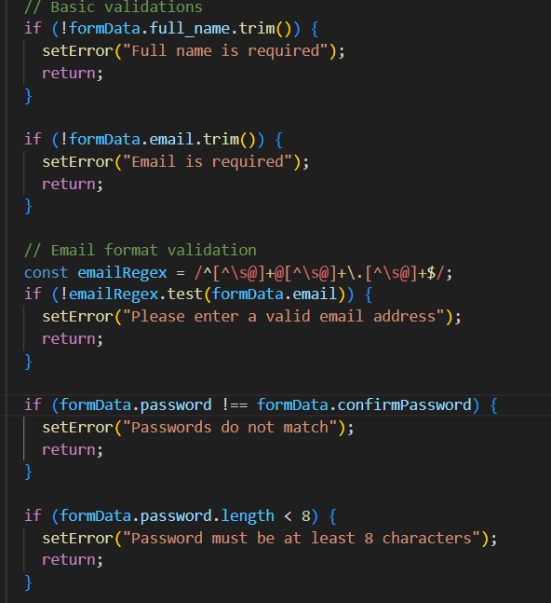
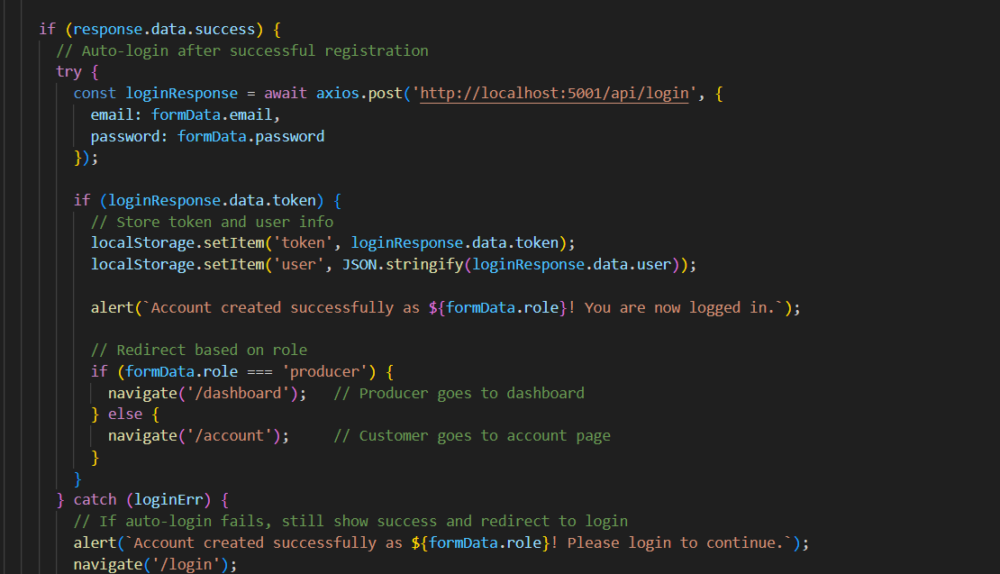
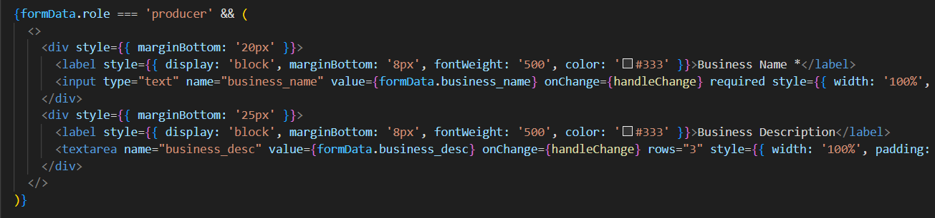
The Register page is where new users can sign up as either a customer or a producer on the Register page. When you get to the Register page the first thing it does is check if you have picked a role on the Register page. If you pick producer on the Register page some extra fields show up asking for your business name and a description of your farm or business on the Register page. This way producers give the information from the very start on the Register page.
Before the Register page sends anything to the backend it does a checks on the Register page. It checks that the full name and email are not empty on the Register page. The Register page also checks that the email is in the format like name@domain.com on the Register page. The Register page checks that the password is least eight characters long and that the password and confirm password fields match on the Register page. If any of these checks do not pass on the Register page an error message shows up. The form does not send on the Register page. This saves time because you do not have to wait for the server to tell you that you made a mistake on the Register page. If all the checks pass on the Register page the Register page sends the registration details to my backend. My backend saves the user to the database. Hashes the password for security. Once the account is created the Register page automatically logs the user in on the Register page. It does this by sending another request to the login endpoint with the email and password on the Register page. This saves you from having to type your details on the Register page. After you are logged in automatically on the Register page the Register page looks at the users role on the Register page. If they registered as a producer on the Register page it sends them to the Dashboard. If they registered as a customer on the Register page it sends them to the Account page, on the Register page.

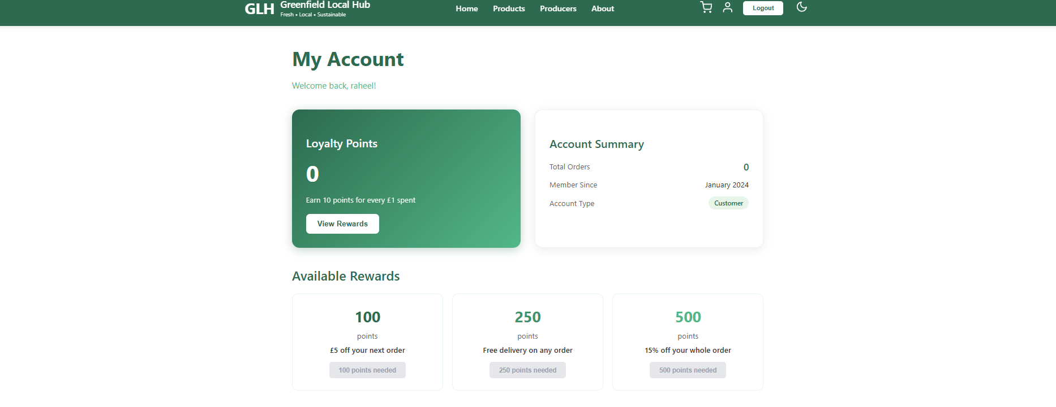
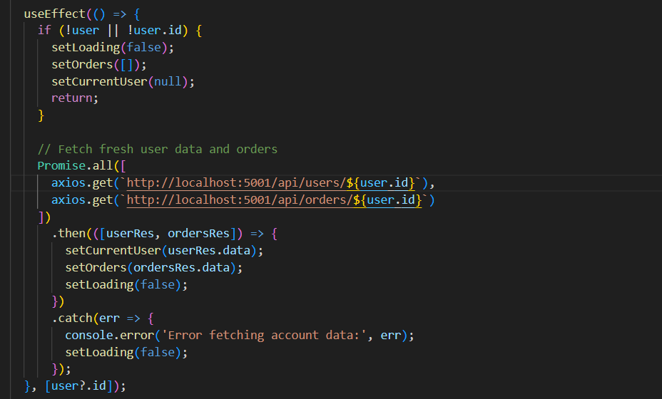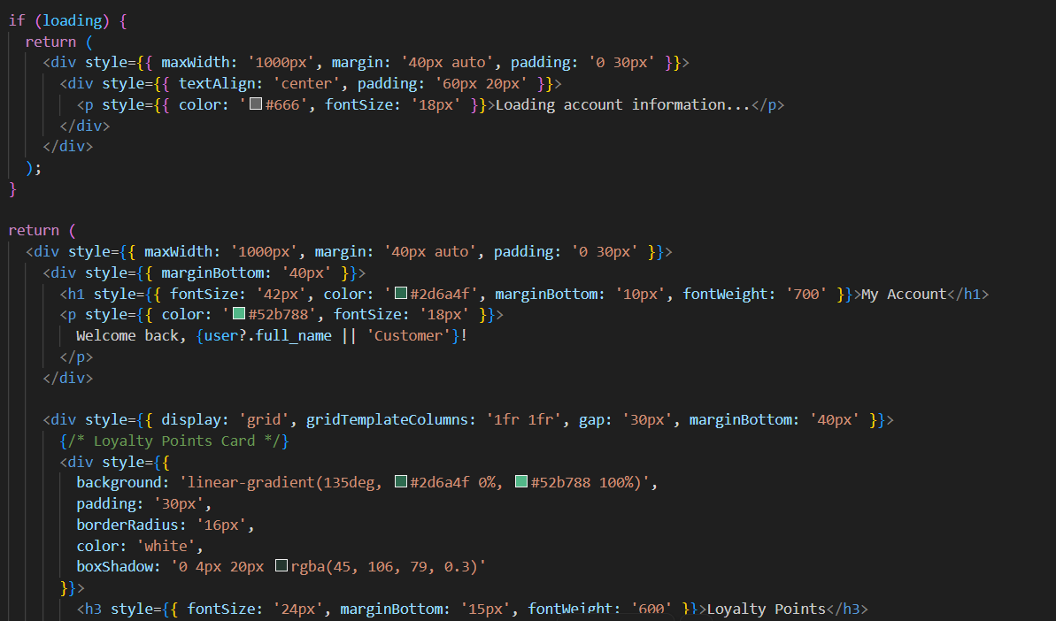
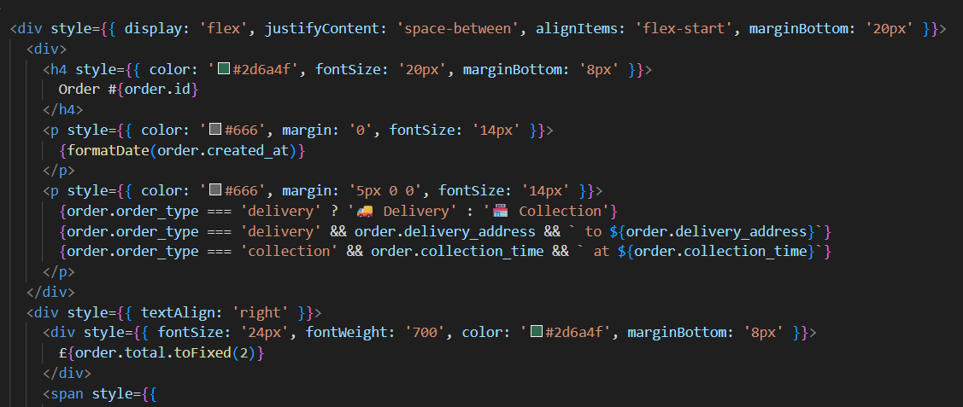
The Account page is where customers can see their order history and loyalty points. When the page loads it checks if a user is logged in. If there is a logged in user it sends two requests to the backend at the time. This means the Account page gets the users information, including their loyalty points balance and a list of all the orders they have placed in the past all at the same time. The Account page gets this information using something called promise.all. This is faster than waiting for one request to finish before starting the other. The Account page shows the loyalty points in a green box at the top of the page. The number of loyalty points comes from the users record in the database.
Below that the Account page has a section showing rewards. The customer can see that 100 loyalty points gets them £5 off 250 loyalty points gets delivery and 500 loyalty points gets 15 per cent off their whole order. The Account page has a button but it is disabled if the customer does not have enough loyalty points. The button text tells them how more loyalty points they need.
Below the rewards section the Account page shows every order the customer has placed. Each order card shows the order number, the date it was placed whether it was delivery or collection the amount and the current status. The status has a colour code so the customer can quickly see if their order is still pending, being prepared, ready for collection or already delivered.
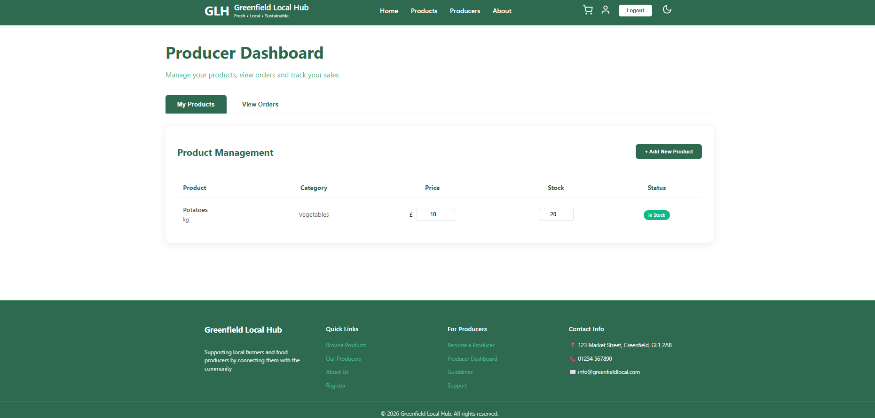
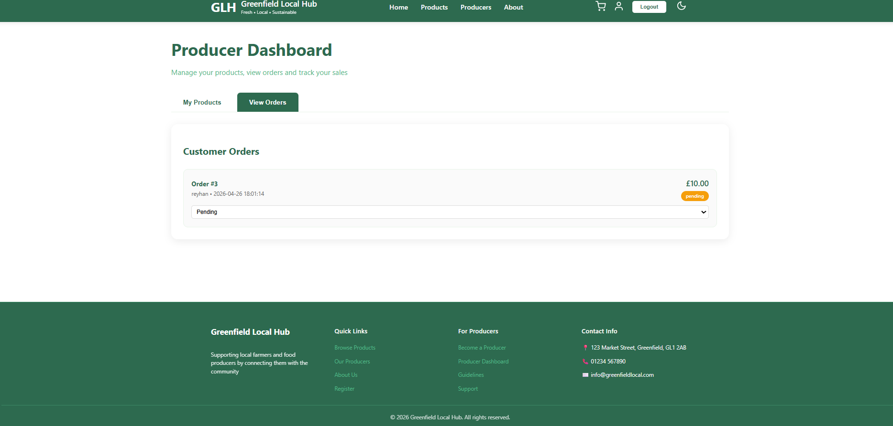
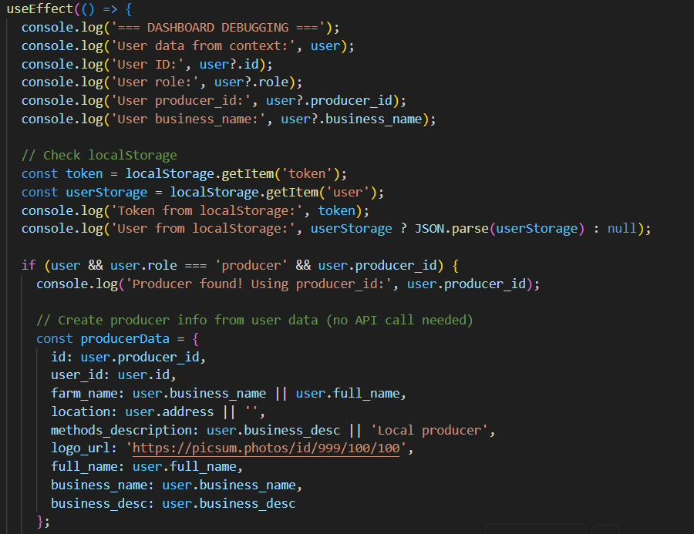
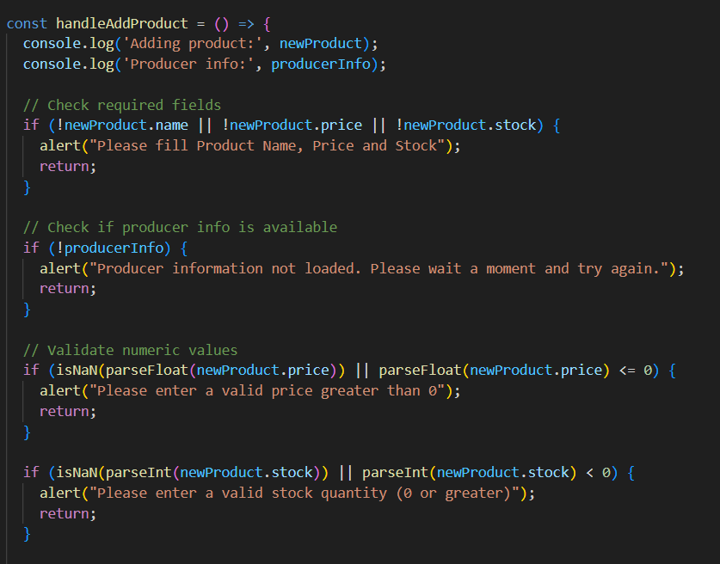
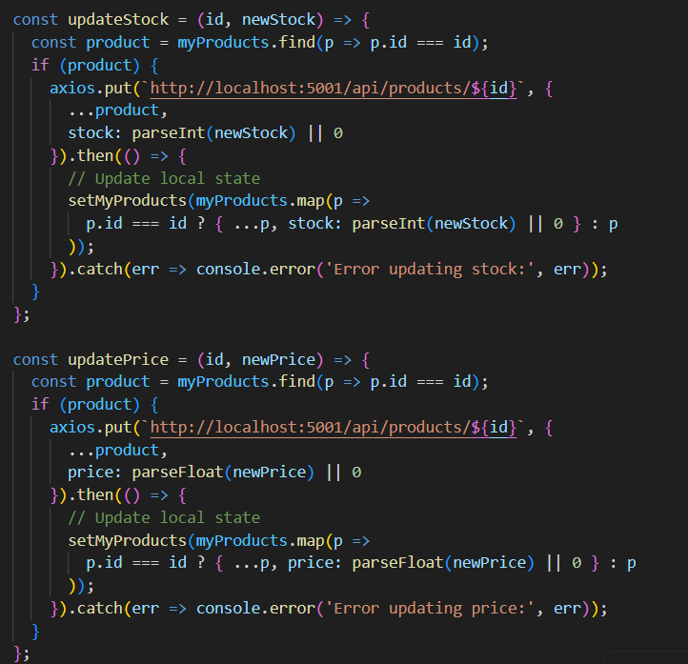
The Producer Dashboard is the tool for farmers and food makers to manage their products. When a producer logs in it checks what role they have and gets their producer ID. It then uses this ID to get the products that belong to that producer from the database. So a new producer sees a list while an existing producer sees only their own products. This is because producers should only manage their stock. The dashboard has two tabs.The first tab shows all the producers products in a table.Next to each product there are boxes where the producer can change the price or stock level. hen they type a number and move away it updates the backend and the change saves right away. This makes it quick and easy to adjust prices or mark items as stock. There is also an "Add New Product" button that opens a form.When the producer fills in the details and submits it sends the product to the backend with their producer ID. The new product then appears in their list immediately. The second tab is for viewing orders. This shows any customer orders that include the producers products. The producer can see the order number, customer name, total amount and current status. There is a menu to each order so the producer can update the status.They can change it from "pending" to "preparing" to "ready" for collection. This gives customers updated information about when their stuff will be ready.
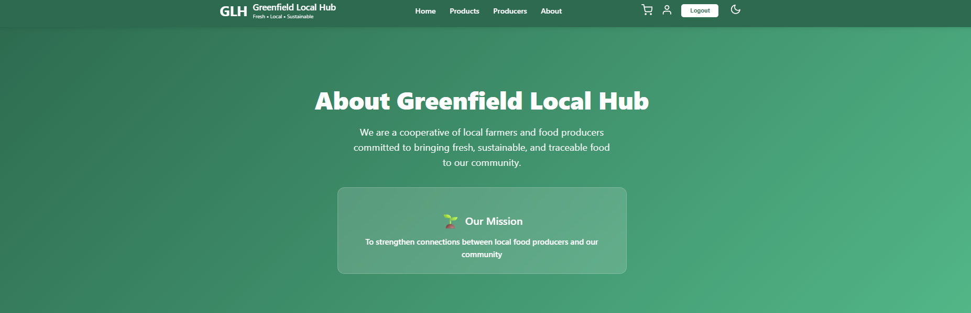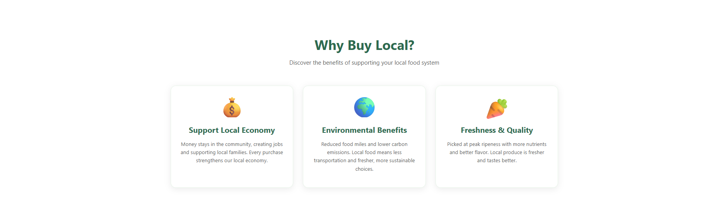
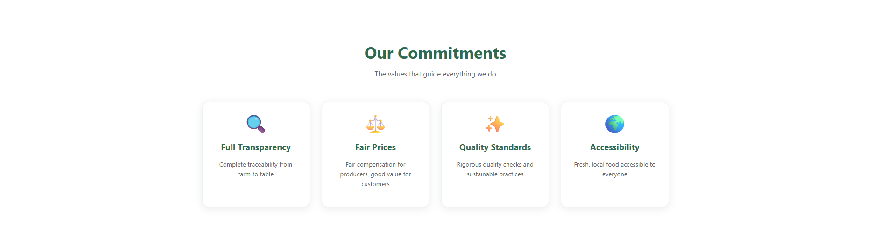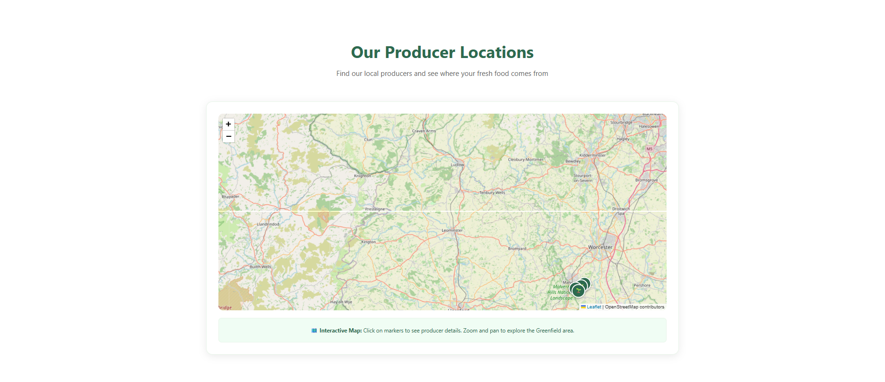
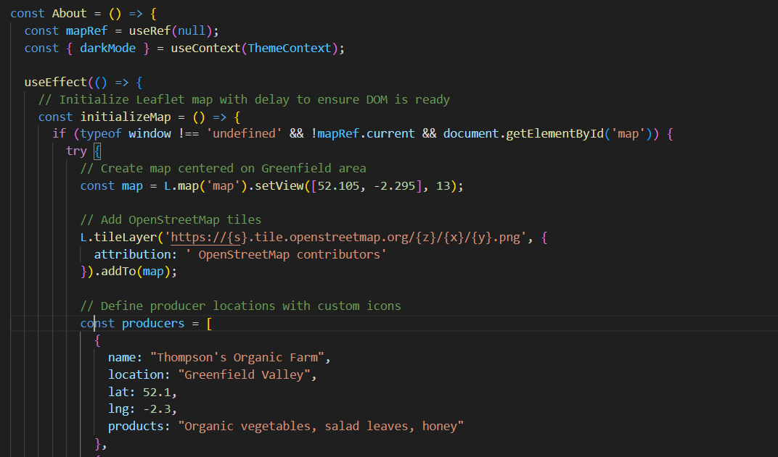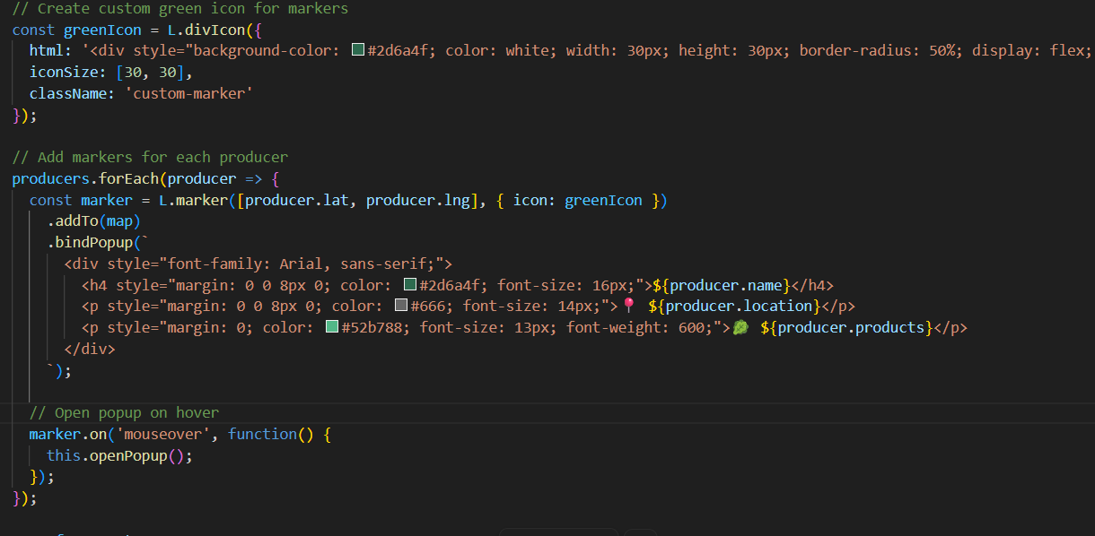
I chose to add an interactive map using Leaflet, which works with free map data from OpenStreetMap. When the page loads, the map initialises and centres itself on the Greenfield area using the coordinates 52.105 latitude and -2.295 longitude. This shows customers roughly where the local farms are located.
I created a list of four producers, each with their name, location, what they produce, and their latitude and longitude coordinates. For each producer, the code adds a marker to the map. I made a custom green marker with a little leaf emoji so it fits with the local food theme. When a customer clicks on a marker, a card appears showing the producers name and basicalywhere they are based and what products they sell. I also added a hover effect so the card opens when the mouse moves over the marker which makes it feel more interactive. The map is completely free to use and does not need an API key and works straight away. Customers can zoom in and out, drag the map around, and click on markers to learn more about where their food comes from.
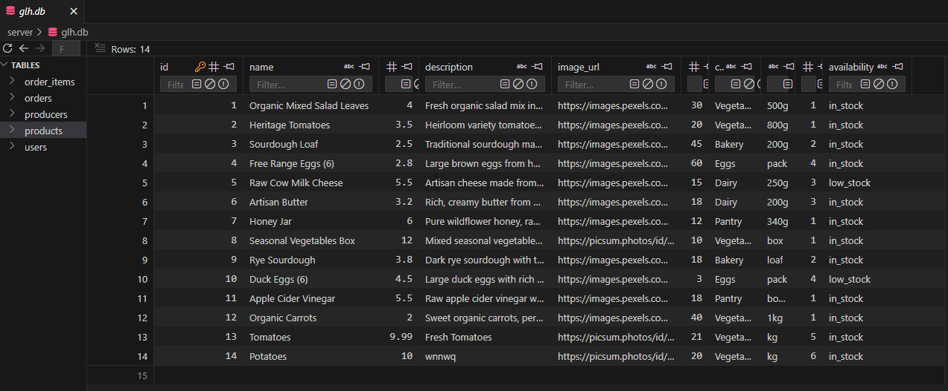
Products table holds information about all the items present on the website. As seen from the screenshot above. There is a unique id number, name, price, description, and image URL assigned to each product. There are 14 products in total at the moment, such as Organic Mixed Salad Leaves, Heritage Tomatoes, Sourdough Loaf etc. Before placing the order the software will check the availability of the item in the inventory. Incasse if there is not enough stock of the required product, the software will reject the order. the website will not sell out of stock items. The image URLs point to the free images found on Pexels.com. To make the database lighter and to increase website loading speed, I decided to save only URLs in the database and leave the actual images on Pexels website.

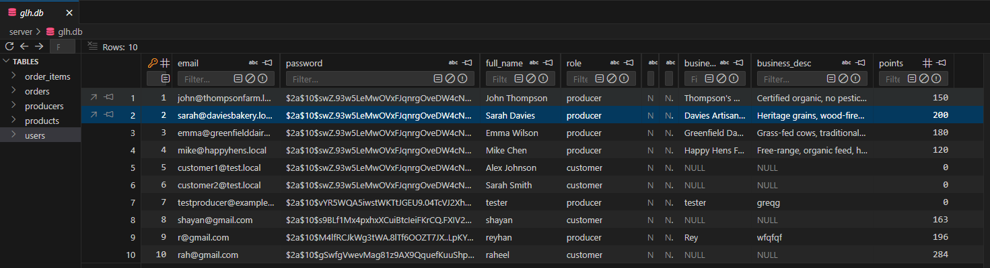
The users table keeps record of all accounts created by the users in the application. From thescreenshot you can see, each user is allocated a unique ID, an email, hash value for the password, name, role type and points. The passwords are saved as hash values using bcrypt. So even if there was any leakage of the information kept in the database no one could retrieve the real passwords due to the encryption applied. It meets GDPR standards. The role value will either be 'customer' or 'producer.' This decides which pages the users will have access to. Like customers have access to shopping and acount history page while producers are directed to the dashboard where they manage their product list and orders.
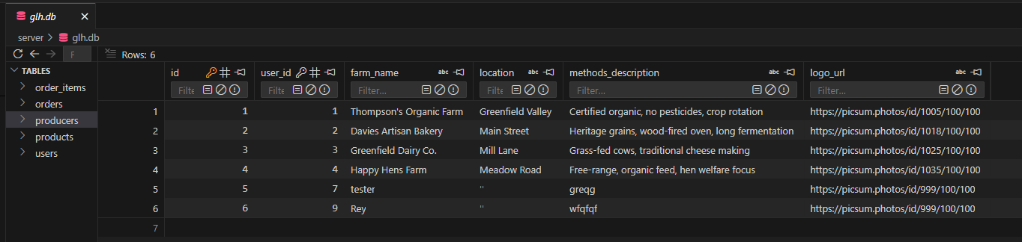
The producers table holds data for each individual producer like the farmer or the manufacturer that sells produce using the website. The screenshot shows the details that have been saved for each producer. these include an ID number, user ID, business name, location, and logo image URL. The user ID provides a relationship between the producers login information in the users table and the details of his or her business. This ensures that each product belongs to one producer and the system can match producers with their products when logging into their account. there are four producers in the site which include Thompson's Organic Farm, Davies Artisan Bakery, Greenfield Dairy Co. and Happy Hens Farm. All four producers have their own locations within Greenfield as shown in the map provided in the About page of the site.

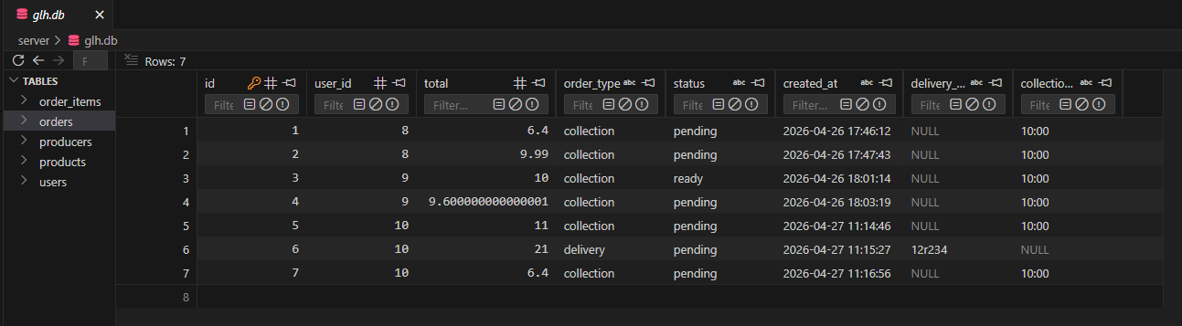
Orders table has all the orders made by the customers. An order contains order ID, user ID referring to the users table, order date, total amount, order status, and order type. Order status field has one of the values like pending, preparing, ready, delivered, and completed. This way customers can see their order status which was one of the requirements identified from the clients market research. The order type field has either delivery or collection based on the choice of the customer. If it is a delivery then the order will have a delivery address and while for the collection option an order will have a pickup time.
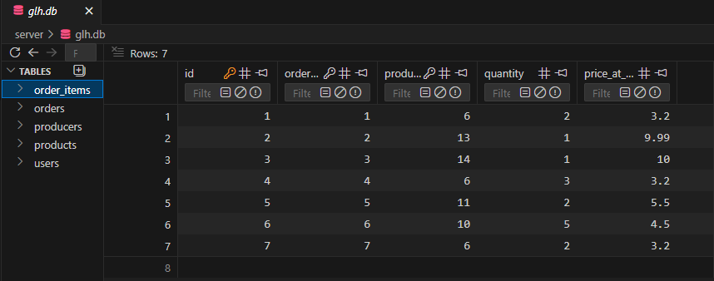
Order Items table contains details about the items that have been used in the order. ID column indicates a unique ID. order_id refers to the ID column in Orders table while product_id refers to the ID column in products. Other columns include quantity of the ordered item and the price at which the item has been ordered. The last column becomes important since prices for the products may change in the future. So with this information the organization can be certain about the price that has been used in the ordering process even if the price is raised to £4.00 from £3.20 per item.
Maintainable and Readable Code:
To keep things easy, I have added comments explaining the role of key functions within the code. For example in server.js of the backend, the comment at the beginning of an endpoint for creating orders describes how the price is calculated, stock checked, order saved, inventory decreased, and loyalty points rewarded. the second developer would be able to get an idea about what exactly is going on while scanning the code.
This project follows certain naming conventions like when working on JavaScript all variable names are written according to the camelCase convention, e.g., fetchProducts, addToCart, and userEmail. Also when using SQLite, tables and column names are written in snake_case, e.g., order_items, producer_id, and full_name as it makes the code look more professional and easy to follow.
With modules, changes to the site can be made easily. There is an individual file for each web page which includes Products.js, Basket.js, and Dashboard.js etc. Then there are the navigation bar and footer modules which I have used on every page. If at any point in the future the footer required changes I will not have to make them in multiple files because all that needs to be done is change one file. It not only saves time but it also reduces the possibility of errors. The code is scalable as well which means the client in the future requires additional functionalities such as product reviews or chats, another developer will be able to pick up from my code and continue easily.
Accessibility and User Experience:
I wanted the website to feel easy and natural to use and not confusing or frustrating. From the very start Ipputted myselff and thought about how a real customer or producer would actually use the site. Would they know where to click? Would they understand what each page does? Would they get annoyed by anything? I tried to answer all of these questions while building the prototype.
The layout of the site stays the same on every single page. The navigation bar is always at the top with the logo on the left and the login button on the right. The footer is always at the bottom with quick links and contact information. This might sound simple but it is important because customers do not have to relearn where things are every time they go to a different page. They know that "Products" will always be in the same spot, and "Account" will always be where they expect it to be.
I went with an earthy and nature related colour palette since my local brand specialises in produce and vegetables. My dominant colour is dark forest green which was used to highlight my buttons and heading fonts. The background is a very light off-white, and the text colours were selected to be dark grey. I avoided going all out with black and white combinations as this would strain the eyes more than necessary. Contrast wise, the page is clear enough for everyone to read and understand without putting too much pressure on the eyes.
All products have descriptive alternative texts that will describe the images for the visually impaired that rely on screen readers to navigate my website. For example, instead of just seeing an image of Organic Mixed Salad Leaves or Heritage Tomatoes, the screen reader will let users know what it is about. Another point worth mentioning is that my website complies with keyboard navigation standards. In other words, you can browse through various elements with the help of the Tab key, and pressing Enter will allow you to click on a button or link.

